**Question 8**

1. Print all the record in the following format

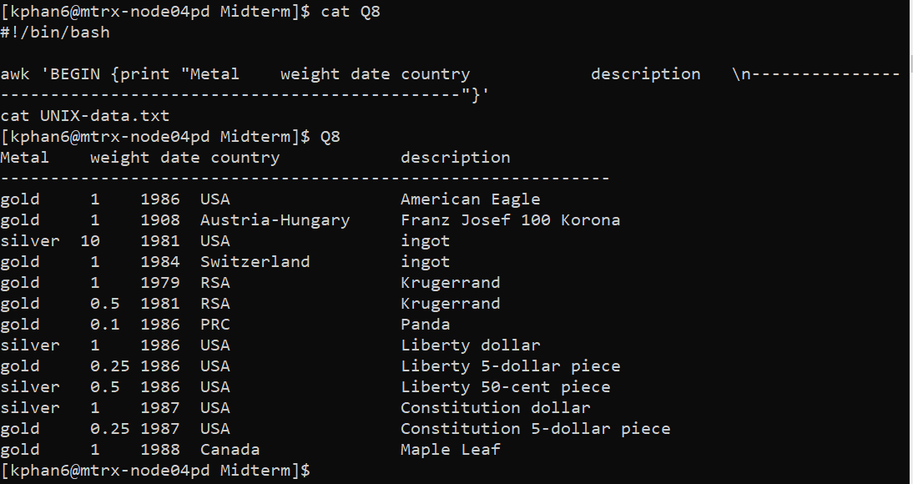

1. Print all records in Upper case

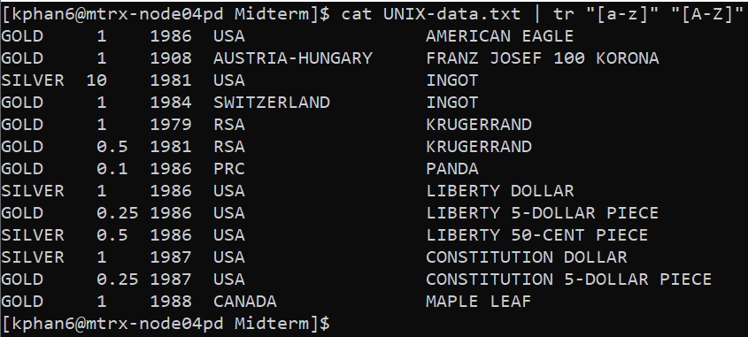

1. Print all the records which their description starts with “L” and their weight is less than “1”

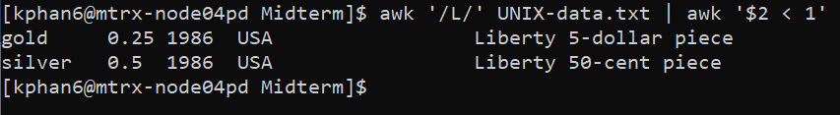

1. Print all records as follow and save them into new file:yourname.txt:

